# Concept and Design

## Overview

### App description

One of the first things you want to do when reaching a new place is to explore the area, and this app allows you to do just that. TrackIt is an app that can be used for both exercise and exploration.

TrackIt allows you to record your travels, as it tracks your route through the area. TrackIt allows you to build a journal of all your adventures with pictures of beautiful scenery that was spotted while exploring.

TrackIt plots your paths by using GPS co-ordinates from your phone. These routes are automatically saved when the tracking is stopped, this allows you to compare your performance over time. Once the tracking of the path has been stopped, the application calculates the distance you have travelled on that path as well as the total time that was taken to travel along that route.

TrackIt allows you to take photos of local monuments and landmarks along your journey through one simple click. The photos taken can then be edited to suit your needs.

**Exercise and Exploration:**

TrackIt was designed with people who enjoy outdoor exercises, such as biking or jogging, in mind, which is why TrackIt allows users to track their and display information about their route. However, TrackIt also allows the explorers to take photos of their surrounds to create a digital journal of their adventures.

**Route Tracking:**

One of the core features of TrackIt is that it accurately tracks the users’ routes with one click of a button. These routes can then be analysed by the users, each of the tracked routes show how far the user has travelled and how long it took for them to reach their destination. The path is then plotted onto the map display on the page.

**Capture Unmissable Moments:**

During your exercise you might come across a monument, landmark or a stunning backdrop that you must take a photo of, which is why TrackIt has a built-in camera function that allows you to take photos of whatever you come across without having to close or minimise the app.

**Include a barcode for installing the app – provided by development environment used**

## Competitors

### RunGo

RunGo is an app for runners who like to travel. It uses turn-by-turn voice navigation, that acts like a virtual running partner, for running routes and city tours. Personal running routes can also be made, meaning the users can choose where to go through the city. RunGo also tracks and logs running stats during the workout.

However, RunGo requires the user to download routes for the cites as it does not work without internet, this is a major problem as lack of internet causes the GPS location to become inaccurate which can cause some problems.

The features that were stated in the paragraph above (such as turn-by-turn voice navigation and path tracking) can cause the application to become very memory intensive, this means that the performance of the phone will be significantly slowed down if the user wanted to open a music app and the camera to take pictures, some users have reported that the RunGo app crashes when other applications are opened.

RunGo has a premium feature that can be unlocked through a subscription fee (which can be monthly or yearly). The premium subscription comes with extra features such as live tracking which shows the users’ progress along the route to others by sharing a link, the premium subscription also allows the user access to verified routes, these are routes that were posted by the community and have been verified to be a good route to follow by other users.

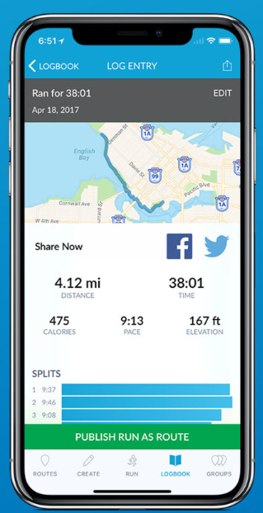User experience (as determined by the reviews posted by users on the app store) for the application is mostly positive, however, the app was far from perfect. RunGo had a lot of issues which caused users to find it hard to use, this could be because RunGo was developed without a target user group in mind. (Day, undated).

RunGo’s turn-by-turn voice navigation allows for accessibility, especially for users that have a visual impairment, as it allows them to run without having to get lost because they were struggling to look at their phone for the route. (Best Health, 2019).

The main thing that was learned from this app was to avoid using highly demanding features such as voice navigation and to avoid adding multiple features that could cause the application to slow down or crash especially if the phone running the application is not strong enough to support the strain.

The inspiration that was taken from the RunGo application is the feature that the application allows the user to track and log their run and given them the time and distance of the runs. The feature was implemented into the TrackIt application because it provides the user useful information that can allow the user to monitor their performance to check to see if they have been improving.

### LiveTrekker

LiveTrekker is an app that creates a digital journal of the users travels so that they can reminisce about their trips on an interactive map that details their trip. LiveTrekker tracks the user as they move, as well as allowing the user to add pictures, videos, audios and text along their journey, this creates a travel diary that can be shared with friends and family.

LiveTrekker also tracks the users’ movements through GPS, but, LiveTrekker also utilises the camera by allows the user to take photos and videos with the apps, it also allows the users to add comments about their journey. LiveTrekker combines all these features into a map which shows illustrations of the users’ full journey. This can then be stored on the cloud and shared with others.

User Experience was one of the most lacking aspects of the LiveTrekker application, as it has had many complaints about the interface being outdated, which made it harder for users to understand the application. There have also been multiple reviews that stated that the application tended to download photos of other users, without warning, when browsing locations. This can cause many problems for the users, such as using up the limited storage space on the phone as well as using up a large sum of mobile data to download all the pictures.

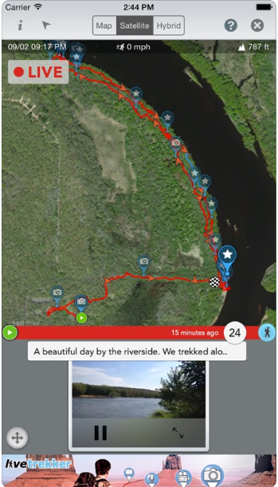The negative aspects of LiveTrekker is that it requires the user to create an account with them to access the application, this could be due to the cloud storage feature of the application. The sign-up feature can be considered a nuisance to some users as they might not want to keep track of another account for an application that might not work as expected.

LiveTrekker also utilises their website for their members to use as a platform to import content or fine-tune journeys, this can be looked at as both a positive and negative aspect of the application. Using two different devices for different features can be considered cumbersome by some users as it means they gave to manage two devices to get the full range of the application.

Inspiration that was gathered from this app was the picture feature. This feature could be considered a great addition to an exercise and exploration application such as TrackIt, as it allows the user to capture the moments around them without having to open multiple applications.

## Requirements

### Persona

Felix Jamerson is a 23-year-old student that likes to travel and explore in his free time, especially during the summer. Felix decides that a part of his daily exercise routine, that he will go to the town nearby his university, a city that is still unfamiliar to him.

He opens the tracking app and press start to begin his journey. On his way to the town, he gets a notification about a statue that was near, he heads to the park the notification had pointed to on the map. The park had a statue he had never seen before, he walks up to the statue to spot a plaque that explains that the statue is of a local hero who has saved hundreds of children during a fire in the town. Felix takes out his phone and snaps a picture of the statue on his tracker app, he wanted to save his photo has part of his journey and wanted to share the statue with his family and friends.

Felix continues his journey to the town centre. When he reaches the park in the town centre, he sits down on the bench and stops tracking his route. When he checks the information of the route he took he found out, he had walked a total of 0.58 kilometres within the span of 30 minutes and 47 seconds, the app also showed the route he took to get to the town centre.

### User stories

As an explorer, I want to see the path I took to get to my destination, so that I can show my friends and family which path I took to get to my destination.

As amateur exerciser, I would like to know how far I travelled and how long I took to get to my destination, so that I can calculate the number of calories I burned to meet my goal.

As an adventurer, I want to be able to take picture during my journey, without having to open other apps, so that I can show my friends and family all the interesting moments I captured during my exploration.

As an explorer, I want to accurately know where my current location is, so that I can tell others where I am and how to get there.

As an explorer, I want to get notification of all the points of interest that is close to me, so that I can visit the places and show my friends and family.

### Core and Enhancement Features

The core features that were identified from the user stories were the plotting of routes, the track information, such as how far the user has travelled, and how long it took for the user to travel the stated distance, another core feature that was identified was the ability to take photos within the app without having to open multiple apps that could potentially slow down the phone, and the final core feature was identified to be the feature which allows users to know where they currently are on the map so that they can share their location with others.

The enhancement features were identified to be the points of interest notification that alerted the user on a nearby monument or landmark that could be an interesting place to visit.

# Prototyping

“The five planes of usability method provide a conceptual framework for talking about user experience problems ad the tools we use to solve them.” (Garrett, undated). It is comprised of five planes which are the strategy, scope, structure, skeleton and surface plane.

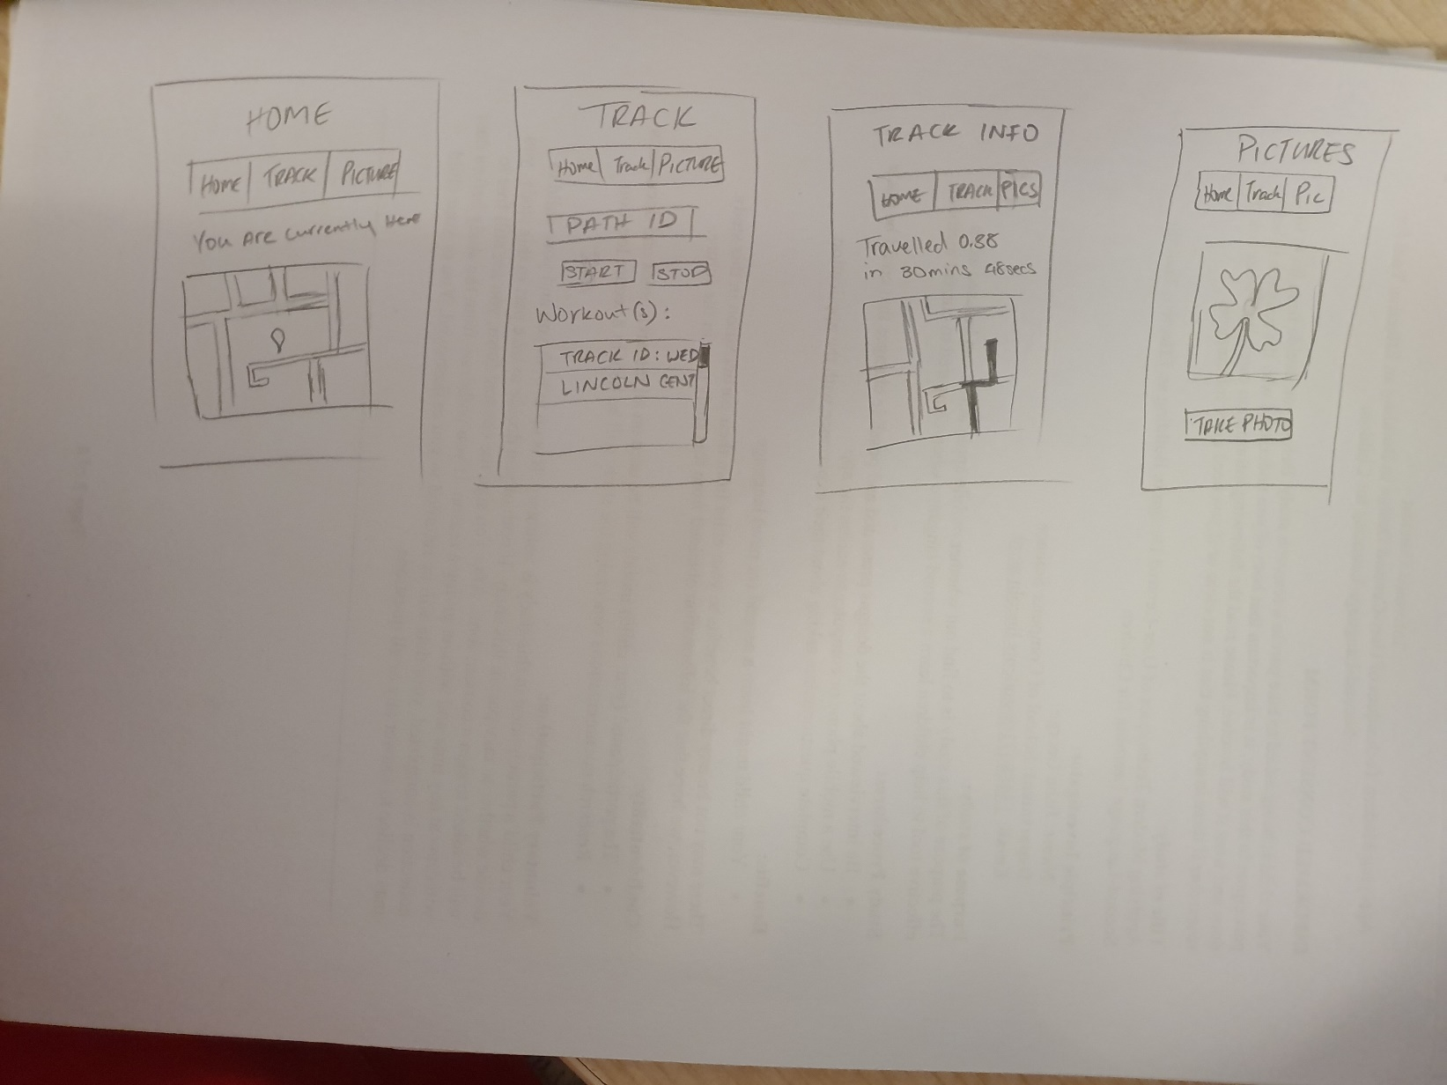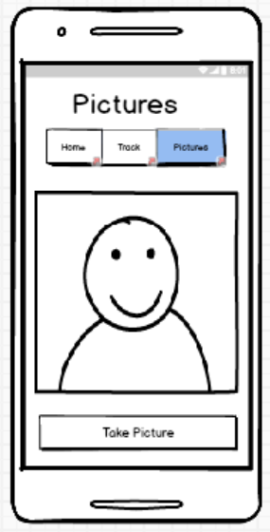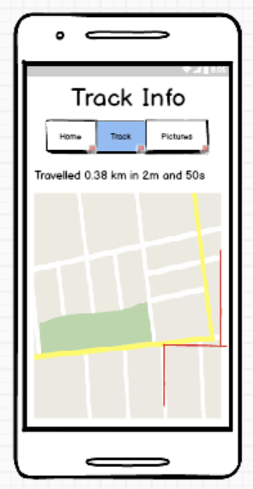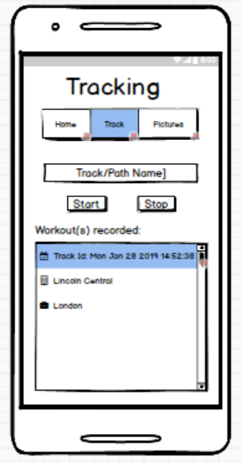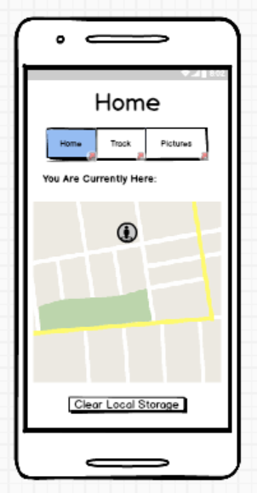The surface plane is where you see all the elements of a webpage or an app, elements such as images and text. These elements may be interactive and can perform functions as a response.

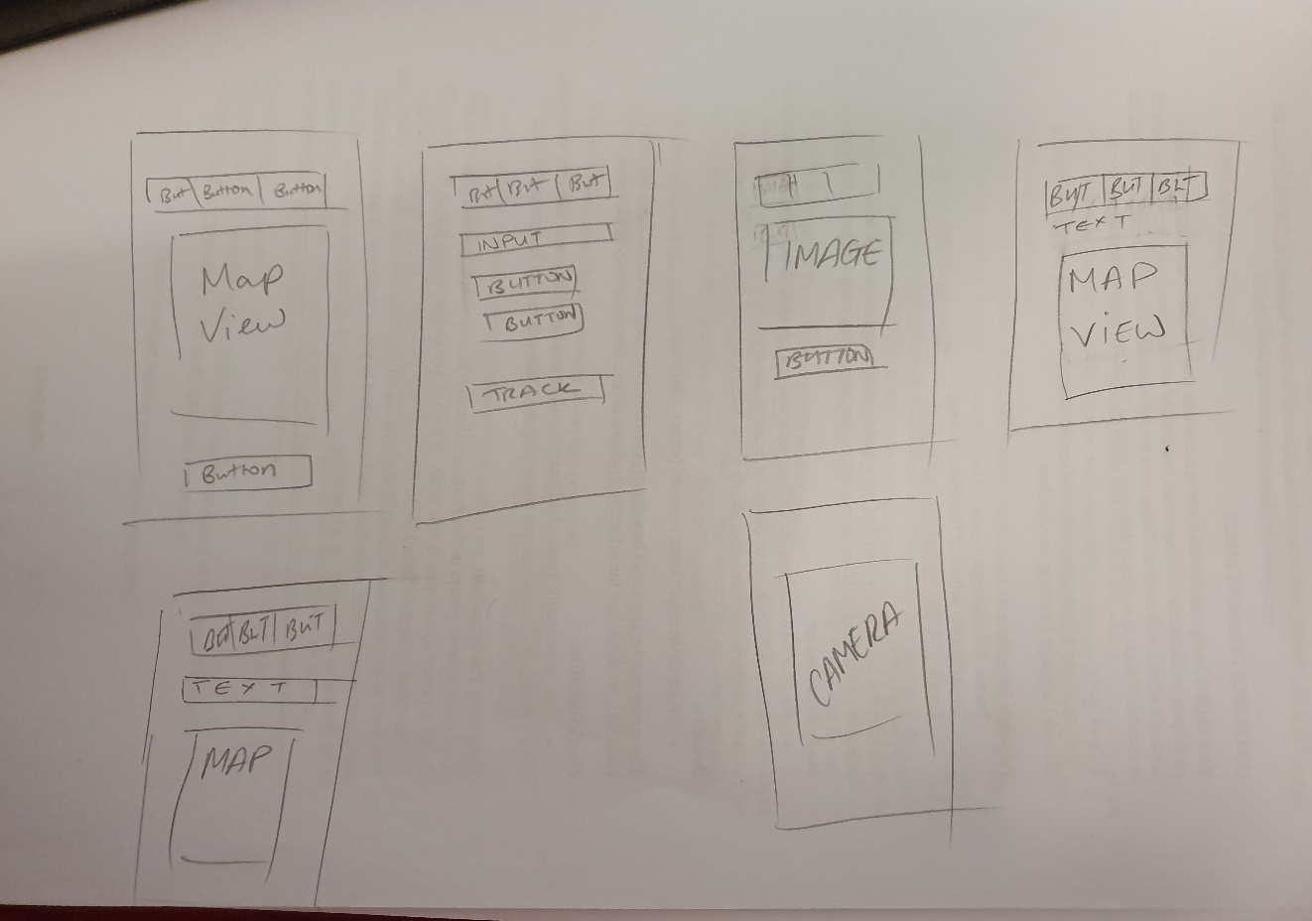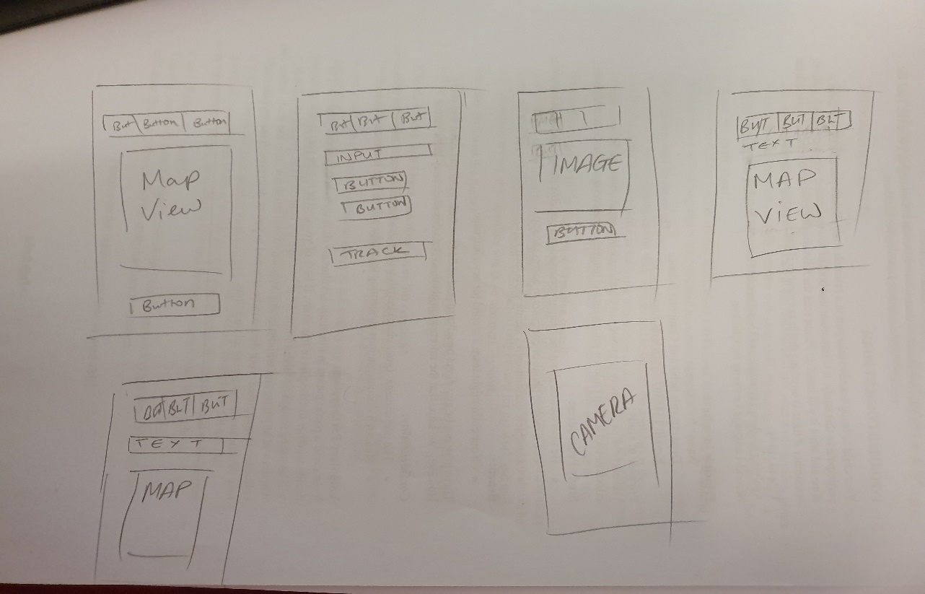The skeleton plane is under the surface plane, this is where the placement of all the elements are. This plane is designed for efficiency, the arrangements of the elements create this effect.

The structure plane is more abstract than the skeleton plane. The structure plane defines how the user gets to certain pages and identifies all the navigation for that page.

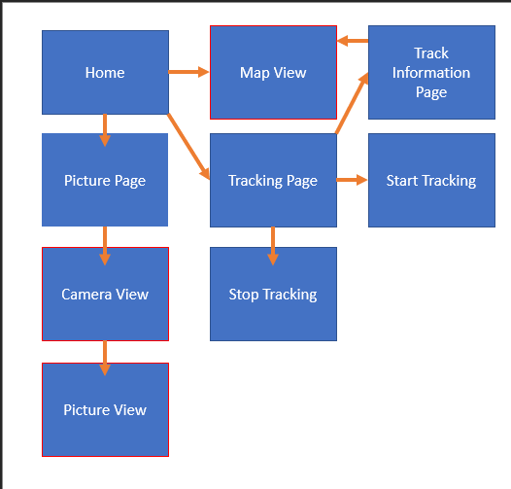 The scope plane are the features and functions that are in the application. The structure plane builds from this plane as it defines the way features and functions are used.

*Trace the path on the map*

*Display information on the path*

*Take photos*

*Display the photo on the app*

*Notify user on Points of Interest*

The strategy plane is the determining factor for the scope plane. This plane integrates what the people get out of the application but also what the user wants from the application as well.

The strategy plane for TrackIt was: *it is an exercise tracking app that allows users to track the paths which can be shared with their friends and family. The paths provide information such as the time it took to travel and how far the user travelled.*

*TrackIt also allows users to take photos of points of interest that they come across.*

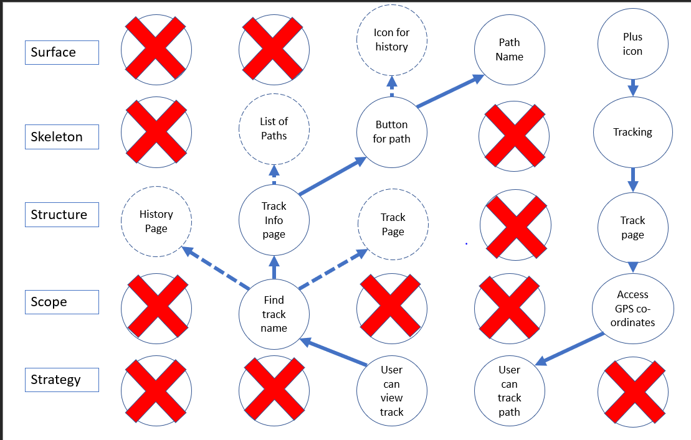The five planes method is built from bottom to top, meaning you work your way up from the strategy plane, all the way up to the surface plane.

The pictures provided are of the final iteration of the application.

**Describe how this led to the first prototype of the app**

The first iteration of the TrackIt application was given to three people that were in the target age group to test out the application. While testing the application feedback was gathered, some of the feedback that was gathered included adding a map view at the front page to show where the user currently was, as this feature was not implemented. Another feature that was suggested was to move the path information to the bottom of the track page so that the capturing pictures had their own page.

**Justify the design decisions at each step – refer to requirements and user testing for justification**

2 – 4 Pages (mainly illustrations)

# Final App

Showcase final version of the app

Include proof of cross-platform deployment – beyond simulation in the editor

Choose to elements of the app to highlight the design and development

Discuss them from a user experience as well as technical perspective

How are they examples of good design?

Why was a feature challenging to develop?

The camera.

How were the elements implemented?

Refer to appropriate academic and non-academic literature (about mobile user experience)

Provide code snippets with explanations

2-4 pages

# Reflection

What effect did the cross-platform nature have on the development?

Specific examples based on experience from the module to discuss positive and negative aspects of the approach

0.5 pages

# Reference

Best Health (2019) RunGo: A GPS Running App Helps the Visually Impaired Run on Their Own. Best Health Mag. Available from <https://www.besthealthmag.ca/best-you/running/rungo-gps-running-app-helps-visually-impaired-run/> [accessed 28 February 2019].

Day, J. (undated) RUNGO. Jaycee Day. Available from <http://jayceeday.com/rungodesign.html> [accessed 27 February 2019].

Garrett, J. (undated). The Elements of User Experience. Available from <http://www.jjg.net/elements/pdf/elements_ch02.pdf> [Accessed 2 March 2019].

**Brief advertisement for the app in style of app store description**

* **Track paths using GPS coordinates**
* **Can be used for running, biking, any type of exercise**
* **Calculates path, distance and total time taken**
* **Allows photos to be taken of local monuments and landmarks along the way as well as let you edit them**
* **Notifies you when you are near a monument**

**Should describe at fairly high level what the app is for and what its core features are**

* **Exercise**
* **Exploration**
* **Track routes**
* **Take pictures**

**Identify two third-party apps seen as competitors**

* **RunGo**
* **LiveTrekker**

**Discuss each app in relation to: Functionality (positive and negative aspects);**

**User experience (positive and negative aspect);**

**what was learned from the app – inspiration, things to avoid**

**Provide one screenshot per app that shows an aspect discussed**

**Outline the usage scenario of the app**

* **Outdoor exercise/exploration**

**Define persona for target audience**

* **Young adults**

**Describe how they would use the app in a scenario**

* **Exercise outside**

**Describe user stories extracted**

**Translate into core features and enhancement features**

**5 planes**

**Link each plane to the one before**

**Describe how user testing was employed- to improve the prototype iteratively, leading to final app**

* **Given to people to target age range**
* **Gathered feedback**
* **Changed to reflect feedback**